Why employees love staying at Marriott
- Employees loyalty, http://fortune.com/2015/03/05/employees-loyalty-marriott/
Marriott isn’t Google. Jobs in the hospitality industry, in Haiti or anywhere, are about as far from Silicon Valley chic as you can get. The company’s employees—more than 200,000 of them, and 361,000 if you include the franchised properties—are scattered around the globe, not concentrated on a cool campus. Rather than writing code, most of them spend their time catering to (1), and cleaning up after, guests. About 85% earn hourly wages; the largest category is housekeeper (2).
Here about what Marriott is doing to attract millennials:
But talk to Marriott employees—or associates, as they’re called—and you’ll hear the word “family” with unusual frequency. They rave (3) about their workplace and their colleagues. And they stick around. The average tenure(4) for a hotel general manager at Marriott is 25 years; industry wide it’s much lower. Some 10,600 people have been there more than 20 years. The company has been on our “Best Companies to Work For” list all 18 years of the list’s existence, something only 11 other companies can say.
Indeed, the next time you find yourself in a Marriott hotel, stop a housekeeper and ask what the guiding principle of the company is, and chances are she’ll say some version of “Take care of the associates, the associates will take care of the guests, and the guests will come back again and again.” That’s J.W. Marriott’s founding philosophy, and while not necessarily a wholly original concept today, it runs through the DNA (5) of the company.
At the hotels, every shift starts with a 15-minute “stand-up” meeting, a chance to check in, share updates, and get pumped (6) for the work ahead. The meetings vary from hotel to hotel but are known to include stretching, music, and dancing (at the Newport Beach Marriott Hotel & Spa, salsa and disco are de rigueur).
One of the biggest events of the year is the companywide Awards of Excellence, an Oscar-style ceremony that recognizes employees from across the globe in four categories. Winners are chosen from a list of nominees by Bill Marriott and flown in for the event, attended by some 800 employees and the entire executive team. (Sorenson says it wasn’t until he attended his first ceremony “that I really understood that there was a depth to this culture that actually starts at the hotels.”)
Many associates will say the best perk (7) is the opportunity to grow a career. Stories of top executives who started out pushing a housekeeping cart or on the bellstand (8) are commonplace. Bob McCarthy, the company’s recently retired chief operating officer, started as a waiter. Ed Fuller, who ran international operations, started as a security guard. Bridget Bilinski, area vice president in the Western region, was a front desk manager trainee (9). Erika Alexander, vice president of the country’s Eastern region, started in entry-level sales.
Vocabulary:
1- To cater : répondre aux besoins  2 –House keeper: femme de chambre | 3 -To rave: chanter les louanges  4 - Tenure: Durée dans le poste  5 - DNA:ADN | 6 - To get pumped: être rempli d’énergie, motivé  7 - Perk: avantage | 8 - Bell stand: Comptoir du concierge (hôtellerie)  9 - Trainee: stagiaire
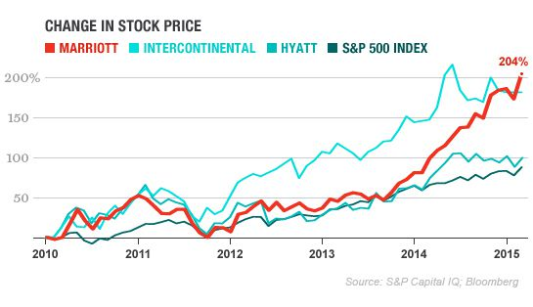
- Reducing Employee Benefit Costs While Increasing Employee Satisfaction, DMRdc.com
As a result, Marriott achieved significant cost savings in employee benefit programs. In addition, the results led to a surprising 12 percent improvement in employee job satisfaction in one year.
Note: 1- S&P = Standard and poor, indice de la bourse de New York
2 - Intercontinental and Hyatt are hospitality companies as Marriott is.

- Describe the Marriott Company.
- Define what motivation means and then classify the different methods used by Marriott to motivate its employees.
- For each method indicate which kind of need it fulfills.
- Explain how those methods have enabled Marriott to answer both employees’ and company’s goals?

